COSC 4350 Artificial Intelligence
Homework #2
Knowledge Representation and Reasoning using Prolog
Due: 03/21/06

Introduction

The purpose of this homework is two fold: 1) to acquaint you with the basics of Prolog programming, and 2) to use Prolog as tool for knowledge representation and reasoning (KRR).
There are two parts in this homework. In Part 1, you need to define Prolog clauses for a number of list processing routines plus work on some simple assignments related to concepts in logic programming and unification. In Part 2, you will use Prolog to represent knowledge and solve problems by letting Prolog do the inference and solution discovery for you. You need to use Prolog clauses to represent a maze and let Prolog find out a path that connects the entrance to the exit. ☺

Specification

Part 1: Basics of Prolog programming

In Prolog, one specify a predicate by writing predicate-name/arity. For example, the predicate append (defined in the lecture notes) is more precisely specified as append/3 because its arity is three.

Part 1A: Interacting with the Prolog interpretor

1. Start up Gprolog or Sicstus Prolog. At the Prolog prompt, type and enter the following: X = 1, print(X).
2. Now, type and enter the following: X = f(a), print(X).
3. In 1) and 2)
a) What types of objects did you pass to print/1?
b) Did print/1 distinguish between the types of objects passed to it?
c) Does the variable X has a fixed type?
d) What can you say about Prolog as far as variable type specification is concerned?
4. Type and enter the following: X = f(X).
5. Type and enter the following X = f(X), print(X).
6. Enter the following: X = f(Y), print(X).
7. In 4) and 5)
a) What happened in 5)?
b) Does Prolog enforce the occur check?
8. Type and enter the following: X = [1,2,3], Y = [0|X]. What was Y bound to?
9. Type and enter the following: X = 0, Y = [1|X]. What was Y bound to?
10. What should be the type of the variable R in [X|R] if X is an atom and [X|R] has to produce a list?
11. Enter the following: member(X,[1,2,3]). Try to get all the alternative answers of X.

Part 1B: Basic Prolog programming

First create a file “my-program.pl”or something. You can write all your Prolog definitions in this file. (A rule of thumb in programming style is that each Prolog rule should be on a separate line of its own.) Now start up Gprolog in the same directory where you saved “my-program.pl”. Before you can “execute” a predicate defined in the program in Prolog, you need to first load the entire program into the Prolog interpreter. To load the program into the Prolog interpreter, type consult(“my-program.pl”) at the prolog prompt. You should see Prolog printing messages about loading your file into the system. At the end, you should see a ‘yes’ printed right above the prolog prompt. Now, you can “execute” your prolog rules by entering a query at the Prolog prompt just like what you did before. All of the following predicates will be used in Part 2.

11. Define the predicate append/3 that takes three arguments L1, L2, and L3, and returns true if the list L3 is the concatenation of the lists L1 and L2. E.g. append([1,2],[3,4],[1,2,3,4]) is true and append([1,2],[3,4],[5,6]) is false.
a) Test your append predicate on the following test cases: i) append([1,2],[2,1],[1,2,2,1]), ii) append([ ],[ ],[ ]), iii) append([a,b,c],[1,2,3],Z), iv) append(X,[a,b,c],[4,5,6,a,b,c]), v) append([1,3,3],Y,[1,3,3,4,5]), vi) append(X,Y,[1,2,3,4]).
b) What are all the possible bindings of the variables you can get in iii) to vi)?
c) From the results you got in b), what can you conclude about a declarative programming language?

12. Define the predicate reverse/2 that takes two arguments L1 and L2 and returns true if the list L2 is a reverse copy of the list L1. This predicate can also be used to produce a reverse copy of L1. You need to use append/3 in defining reverse/2 to make life easier.
a) Test your reverse predicate on the following test cases: i) reverse([ ],[ ]), ii) reverse([a],[a]), iii) reverse([a,b],[b,c]), iv) reverse([a,b],X), v) reverse(Y,[b,a]).
b) What are all the possible bindings of the variables in iv) and v)?
c) What happened when you tried to get more bindings of Y in v)? Although Prolog is a declarative language at heart, can we ignore the procedural meaning of a piece of Prolog definition?

13. Define the predicate iright/3 (“immediate right”) that takes 3 arguments X, Y, and L, and returns true if Y is immediately to the right of X in the list L. E.g. iright(1,2,[1,2,3]) is true, iright(2,1,[1,2,3]) is false.
a) Test your iright/3 predicate on the following test cases: i) iright(1,2,[ ]), ii) iright(a,b,[a,b,c]), iii) iright(a,b,[b,a,b]).

14. Define the predicate next_to/3 that takes three arguments X, Y, and L and returns true if X is next to Y in the list L. E.g. next_to(1,2,[1,2,3]) is true, next_to(1,2,[2,1,3]) is true, but next_to(1,2,[1,3,2]) is false. You must use iright/3 in defining next_to/3, which makes the definition very simple (and non-recursive).
a) Test your next_to/3 predicate on the following test cases: i) next_to(1,2,[ ]), ii) next_to(a,b,[a,c,b]), iii) next_to(a,b,[b,a,c]).

Part 2: Using Prolog for knowledge representation and reasoning

You should keep all of the predicates defined in Part 1 in the same file. Add any new Prolog code to the same file containing the predicates defined in Part 1. Before you solve a puzzle and get the answer or answers for it, you should first load all the Prolog code (including the code relevant for solving the puzzles) into the Prolog interpreter like you did before in Part 1.

Part 2: Getting out of a maze

In this problem, you will learn how to use Prolog to represent a graph and solve a simple path finding problem. Below is the maze we want to represent using Prolog (unit) clauses.

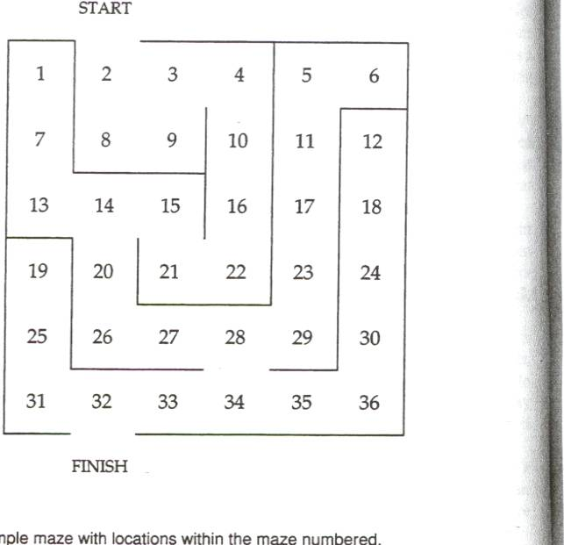

In the maze, all the (invisible) number grids are connected to each other except at places where there is a wall. For example, 2 is connected to 3, 3 to 9, but 13 is NOT connected to 19 because of the wall, and 2 is NOT connected to 9. Also, START is connected to 2 and 32 is connected to FINISH.

Please follow the instructions below for solving this problem:

1) To represent the fact that a number grid x is connected to a number grid y (and similarly for START and FINISH), you can define a unit Prolog clause for each fact as: edge(x,y), meaning that there is an “edge” between x and y. Also, edge(x,y) needs to satisfy the constraint that x < y. Start is smaller than all numbers which are smaller than Finish. Reminder: each such fact should be on a separate line.

2) Now, define the predicate connected_to/2 that takes two arguments X, Y and returns true if there is an edge between the number grid X and the number grid Y in the maze, OR VICE VERSA. You should use edge/2 to define connected_to/2. This definition is very simple.

3) (This part is a bit more difficult.) Define the predicate path_aux/4 that takes four parameters X, Y, L0, and L1. X, Y, L0 are input parameters while L1 is an output parameter. Given a current (partial) solution path L0, this predicate is supposed to give us a complete solution path L1 that connects the two points X and Y in the maze in REVERSED direction. So, L1 is a completion of L0. For example, path_aux(2,4,[2],[4,3,2]) is true but path_aux(2,4,[2],[2,3,4]) is false. We are going to understand this predicate in terms of its procedural semantics. It should work like this:
i) starts from point X in the maze and checks what X is connected to. Suppose X is connected to Z in the maze.
ii) make sure that Z is NOT already in the partial solution L0, if Z is already in L0, we will backtrack to find a different Z that is connected to X but not in L0, and if there is not such a Z, the entire path_aux/4 predicate fails. If Z is not in L0 (i.e. we don’t have loops in the current solution L0), we go to the next step.
iii) Now, we augment the current solution path L0 by adding Z to the FRONT of it. And, we recursively start our path completion again beginning at Z with the current partial solution that is Z added to the front of L0 (hint: go back to question 8) in Part 1 if you don’t know how to add an element in front of a list in Prolog).
iv) path_aux/4 should stop when X = Y. That is, when we have arrived at our destination Y. At this point, it should return L0 as the solution since it has completed the partial solution path.
v) if your implementation is correct, the final solution path returned by path_aux/4 is actually an inverse of the path starting at X and ending at Y (i.e. the path that starts at Y and ends at X).

4) Define the predicate path/3 that takes three arguments X,Y, and Solution. It returns a solution path Solution that connects the points X and Y in the maze. This predicate definition is very simple. You just need to make a call to path_aux/4 using [X] as the current partial solution. That is, we begin at X and recursively add one node (at a time) in front of and connected to the current node being explored in the maze.

5) Now, define the solve_maze/1 predicate which takes one OUTPUT parameter L: the solution path from start to finish. It works like this:
i) find a path using path/3 that connects ‘start’ to ‘finish’. Store the solution path in L0.
ii) reverse L0 (since L0 is actually the inverse of the path going from start to finish) and bind the result to L.
iii) print out the solution path L using the predicate write/1. Write/1 takes one argument and simply prints out its content like print/1 in Part 1.

6) Now, solve the maze problem using solve_maze. What are the two possible ways to get out of the maze (i.e. the two possible answers of L)?

Important Notes

Should you decide to represent the knowledge in each puzzle in your own way, you also become responsible for explaining your construction in details (at least as much as my explanation provided above). I will take points off of a solution that looks obscure to me. Also, copied materials will be dealt with according to the policy mentioned in the syllabus concerning cheating. Discussion with classmates is ok but not copying.

Bonus

Students who turn in a statement (max 2 pages) addressing the following issues: 1) Why is KRR an important issue in AI?, 2) What are some of the benefits or drawbacks of using logic as a KRR tool, and 3) How is KRR related to problem solving by searching in AI? (Hint: think about the relationship between automated theorem proving and searching). You will receive a fair amount of bonus if you turn in such a statement. You will get the bonus only if you have completed the assignment first.

Hints

1. Start working on this homework now.
2 Start at Part 1, thoroughly test your definitions of the various predicates to make sure they are working properly before beginning Part 2.
3. If you have very little experience in Prolog, this assignment could be more difficult for you than it needs to be. If so, please contact me for help.
4. The more you bug me about this assignment, the higher is your chance of getting a good score.

What to turn in

You need to turn in the following for this assignment (in no more than a total of 6 pages):
1) Your listing of all the relevant Prolog code for this assignment and its comments.
2) A trace of all the output generated in part 1 (plus all the answers to the questions) and the output generated in part 2.
3) Your write up on what you have learned in this assignment, and the major barriers (if any) that came your way. (Note: This is not the same as the bonus questions)

